
ADDIS ABABA INSTITUTE OF TECHNOLOGY
CENTER OF INFORMATION TECHNOLOGY AND SCIENTIFIC COMPUTING
DEPARTMENT OF SOFTWARE ENGINEERING
Evolution of the Internet and website standard

Prepared by: - Michael Solomon
ID number: - ATR/8786/11

Submitted to: Mr. Fitsum Alemu
February 2020

Abstract
The Internet is over four decades old. The Internet that we know today to be on this stage passed through major evolutionary changes. The roots of the Internet go back a long way, mostly back to around 1960’s. before then, even though there were little inventions that has significant indirectly to the Internet, there was basically no Internet. Life was basically different on different aspects before the invention of Internet. Late 1960’s ARPANet was the invented which is the predecessor of Internet, Internet got its new name from the term Internetworking.
Websites emerged so quickly soon after Internet was made public to the people. Websites are collection of webpages that have specific goal to address to the user. Websites must be designed in a way to attract users. The quality of a website must be judged with its intended purpose, though the quality of a website judgment might vary from person to person, there are guidelines that are used to evaluate the value of a website

Table of Contents
Introduction 1
Evolution of The Internet 2
Life before Internet 2
Late 1960’s – Emergence of ARPANet (predecessor of Internet) 3
NSFNET era 4
The INTERNET 5
World wide web 6
Websites 8
Guide lines for evaluating the value of a website 8
1. Accessibility 8
2. Design 8
3. Content 8
3.1. Accuracy 9
3.2. Authority 9
3.3. Objectivity 9
3.4. Currency 9
3.5. Coverage 9
4. Interactivity 10
5. CREATIVENESS/ORIGINALITY 10
Evaluation of a few popular websites 10
Wikipedia 10
Currency of Wikipedia 11
Objectivity of Wikipedia 11
Authority of Wikipedia 11
Accuracy of Wikipedia 12
Coverage of Wikipedia 12
Purpose of Wikipedia 12
Accessibility of Wikipedia 12
Web design of Wikipedia 12
Judgment of Wikipedia 13
Judgment regarding the content of Wikipedia 13
Judgment regarding the design of Wikipedia 14
Gebeya 14
Currency of Gebeya 14
Objectivity of Gebeya 15
Authority of Gebeya 15
Accuracy of Gebeya 15
Purpose of Gebeya 15
Accessibility of Gebeya 15
Web design of Gebeya 16
Judgment of Gebeya website 16
Judgment regarding web design of Gebeya website 16
Judgment regarding content of Gebeya website 16
Conclusion 17
Reference 18

List of Figures
Figure 1: showing difference between life before and after Internet 2
Figure 2: Wikipedia logo 11
Figure 3: snippet of the "contact us" section of wikipedia 11
Figure 4: The home page of Wikipedia which shows the different languages 13
Figure 5: The logo of Gebeya 14
Figure 6: The snippet shows the navigation bar of Gebeya 15
List of Tables
Table 1: summary of the evolution of Internet in short 7

Introduction
Life before Internet was a bit hard in majority extents this document deals with how the Internet get to the point in which the world knows today.
This document contains two phases the first phase deals with the history of the Internet (the evolution of the Internet from ARPANET to the World Wide Web) by describing the major significant changes that happened throughout the evolution on the Internet and the second phase focuses on overview of evaluation and judgment on one major pillar of the Internet which are websites.
The first phase (evolution of Internet) starts by showing what life actually was before the emergence of Internet to get better grasp of what Internet brings to the world, and it describes significant evolutionary changes that took place to get to the Internet that we know today and proceeds to the point where web development emerged.
The Second phase focuses on website and contains observation and assessment of some chosen popular websites using web archive as a reference. It also gives little description of the 12 categories of the websites by inferring 5 examples for each category. At the end the document gives the guideline for evaluating a website and evaluation along with judgement of a few popular websites are provided.

Evolution of The Internet

Life before Internet
To better understand the need for the Internet, it is important to know what life was without the Internet. Life before the Internet for everyone, including engineers, was very different to today. life seemed to be less busy, less stressful and, frankly, more enjoyable. But, of course, other things were a lot harder. Unlike today we have never had an easier time accessing any information, shopping, work or start a business. Among activities that are eased by the emergence of the Internet:
- You had to leave the house to socialize
Before the Internet, doing majority of things required an individual to get off his/her backside and leave the house. Shopping for things would take the individual to a local store, watching a movie required the individual to go to a cinema. The majority of things being done outside allow the individual to meet and make friends with people in person which enhances socialization. The Internet provide a means to do all things sitting on the sofa without going anywhere.
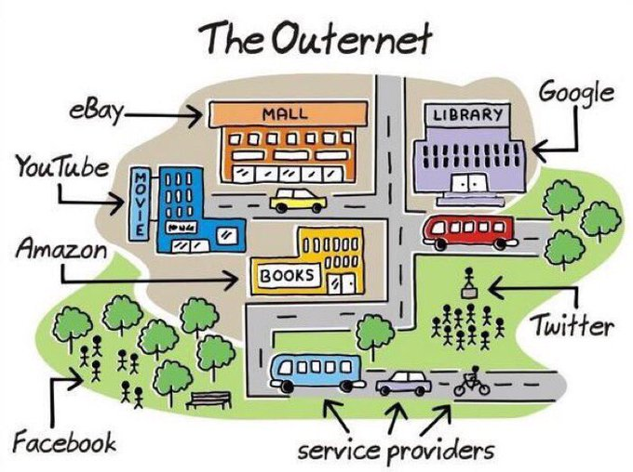
Figure 1: showing difference between life before and after Internet
- Information’s were posted on a wall
Before the Internet, if you wanted to put up some information for everyone to see you actually needed to physically affix it to a wall.
- Online shopping
Before the Internet was introduced there was no way of people buying things without physical meeting with the seller. The emergence of different e-commerce apps makes it easier to people after The Internet. buying and selling things made a lot easier because of the Internet.
Amazon was just a river back then, but now when Amazon is inferred the first thing that came to majority of the people is the shopping store.
The following topics describes the journey the Internet, that makes millions of computer users to connect to one another, reaches to this point of time by stating significant evolutionary changes that it passed.

Late 1960’s – Emergence of ARPANet (predecessor of Internet)
The first recorded description of the social interactions that could be enabled through networking was written by J.C.R. Licklider in August 1962. Licklider’s objective was to create globally interconnected set of computers through which everyone could quickly access data and programs from any site. In spirit, the concept was very much like the Internet of today.
Advanced Research Projects Agency (ARPA) is a US agency first led by Dr. J.C.R. Licklider to help fund and promote research. In late 1966 Roberts develop the computer network concept and quickly put together his plan for the “ARPANet”, publishing it in 1967. Computers were added quickly to the ARPANET during the following years. ARPANet which is the early version of Internet is a term used to describe a structure that handles the major traffic in networked system.
ARPANET had two major objectives.
- To create a communication system that could survive a nuclear attack or natural disaster
- To provide communication links to its users in remote locations ‘resource-sharing’
ARPA linked together mainframe computers to form a communications network. To this point the ARPANet was not made public to the people. In October 1972, Kahn organized a large, very successful demonstration of the ARPANET at the International Computer Communication Conference (ICCC). This was the first public demonstration of this new network technology to the public.
It was also in 1972 electronic mail, was introduced. From there email took off as the largest network application for over a decade.
By 1972, the network was essentially complete. During and after the construction of the ARPANET, other significant developments in networking technology were under way. The ‘Internetworking’ project began in late 1973.The key challenge of the ‘internetworking’ was inability to find a way of transitioning from a network like ARPANet to different networks. Two solution were provided to overcome the challenge.
- One was to allow networks wishing to join the new ‘Internetwork’ to retain their existing protocols and simply construct ‘gateway’ computers that would translate those into a common set of conventions.
- The other was to require that all candidate networks adopted a new set of protocols (which acts as a common language for different networks).
The second option was adopted, Kahn decided to develop a new version of the protocol which could meet the needs of an open-architecture network environment. This protocol would eventually be called the Transmission Control Protocol/Internet Protocol (TCP/IP). While National Science Foundation NCF tended to act like a device driver, the new protocol would be more like a communications protocol.
TCP and IP evolved and become the common network of the networks. In this way TCP/IP became the cornerstone of the new ‘network of networks. So as long as a given network ‘spoke’ TCP/IP it was free to join the Internet.
In March 1981, It was announced that all ARPANET hosts would be required to adopt TCP/IP by January 1983. Not all sites were able to meet the deadline, but by the middle of 1983, every ARPANET host was running TCP/IP which is why April 1983 is said to mark the beginning of the Internet that everybody use today. In 1980’s Speed of ARPANet is no longer sufficient. There was a need of faster network.

NSFNET era
National Science Foundation (NSF) created a new high-speed network NSFNet
The objective of NSFNet was:
- To interconnect supercomputing centers so they could access one another’s resources.
- To give academic and research Centre’s access to one another for the purposes of exchanging information
In early 1990’s ARPANet and NSFNet were linked together but NSFNet had a better and faster backbone, by early 1990’s February 28 ARPANet was officially decommissioned and ARPANet was fully replaced by NSFNet.
The major reason of the complete replacement of NSFNet by ARPANet was In 1994, the NSF implemented a plan to allow Internet service to be taken over by commercial companies known as ‘Internet Service Providers’ (ISPs), each of which would operate its own backbone which in turn lowers the need of the ARPANet backbone. Customers would connect to one of the companies’ backbones, and the ISPs would operate a set of gateways at which a number of ISPs could interconnect their systems, allowing traffic to pass smoothly from one network to another.

The INTERNET
The predecessor of the Internet was ARPANet. The term Internet was officially adopted in 1983. The process of linking a collection networks is called Internetworking. This term is where the Internet got its name.
the Internet was based on the idea that there would be multiple independent networks of rather arbitrary design. In this approach, the choice of any individual network technology was not dictated by a particular network architecture but rather could be selected freely by a provider and made to interwork with the other networks through a meta-level “Internetworking Architecture”.
The idea of open-architecture networking was first introduced by Kahn. In an open-architecture network, the individual networks may be separately designed and developed and each may have its own unique interface which it may offer to users. Each network can be designed in accordance with the specific environment and user requirements of that network. There are generally no constraints on the types of network.
The Internet world and the real world existed as parallel universes. Most people outside of the Internet world had no knowledge of the network and even if they did, they would have found it difficult to gain admission to it. Two developments clear the distinction between the two universes and caused them gradually to merge. The first was the NSF's decision to hand the backbone over to ISPs. This meant that lay people could now access the network generally via slow dial-up connections. The second development was the arrival the World Wide Web.

World wide web
The Web was the creation of a single individual the physicist and computer scientist Tim Berners-Lee. Berners-Lee's idea was to take an established technology called ‘hypertext’ software which created documents with extensive cross-referencing between related sections of text and associated graphics and make it work across the Internet. at the end of 1990, Berners-Lee created a working prototype of what he dubbed the ‘World Wide Web’, in three months
Despite all this, dissemination of the Web in 1991–1992 was slow and remained so until the spring of 1993, when Marc Andreessen and Eric Bina, released Mosaic, a browser they had written for the Web. Although Mosaic was not the first graphical browser, it was the first one to display graphics inline (i.e. as an integral component of a page, rather than in a separate window).
The launch of Mosaic was a landmark moment in the evolution of both the Web and the Internet. It provided a dramatic illustration of the Web's potential for both publication and commerce. The use of Internet increased after the emergence of Mosaic. At that time, 6.7% of the global population had access to the Net. Most of them connected to the network via slow, noisy, and low-bandwidth dial-up lines. Most mobile phones did not connect to the network, and the few that did, connected via very limited Wireless Application Protocol (WAP) connections. Given these realities, the Internet of the late 1990s was very much an immature technology.
In order to make the Internet possible, a whole range of problems had to be solved. For example, ways had to be found to allow interactivity between browsers and servers; to facilitate personalization of web content; and to overcome the problem that the httpprotocol was both insecure (in that communications between browser and server could be intercepted and monitored by third parties) and stateless (i.e. unable to support multistep transactions).
In time, solutions to these problems emerged in the forms of: ‘cookies. HTTPS (an encrypted version of the basic httpprotocol - the s stands for secured); the evolution of browsers with capabilities added by specialized ‘plug-ins’ which enabled them to handle audio and video and other kinds of file; and, eventually, JavaScript, which effectively turned web pages into small virtual machines.
This solution that somehow fix the problems arised when The Internet was introduce led to the Internet that the world is using to this particular second. Eventually www was made public to the people. In 1992 The first audio and video are distributed over the Internet. The phrase "surfing the Internet" is popularized. This led to the high increase in number of websites on the Internet.
Table 1: summary of the evolution of Internet in short
Year (GC) | Events happened
1965 | Two computers at MIT Lincoln Lab communicate with one another using packet-switching technology.
1968 | ARPANet is emerged
1972 | Ray Tomlinson introduces network email.
1974 | The first Internet Service Provider (ISP) is born with the introduction of a commercial version of ARPANET, known as Telenet.
1982 | Transmission Control Protocol (TCP) and Internet Protocol (IP), as the protocol suite, commonly known as TCP/IP, emerge as the protocol
1983 | The Domain Name System (DNS) establishes the familiar .edu, .gov, .com, .mil, .org, .net, and .int system for naming websites. This is easier to remember than the previous designation for websites, such as 112.763.283
1987 | Cisco ships its first router
1990 | Tim Berners-Lee develops HyperText Markup Language (HTML).
1991 | CERN introduces the World Wide Web to the public.
1993 | Mosaic browser was released.

Websites
To this point millions of websites are found on the Internet. and different startups launch and become famous over the globe. The likes of YouTube Instagram twitter are among the successful medias which have millions of users. The emergence of the Internet made many things possible. Though it comes with some side effects as well.
This document focuses on the standard of the websites which are primarily the subjective and objective aspects which should be best to be included in every website and judgment and evaluation of some popular website is provided along the way.

Guide lines for evaluating the value of a website
With the increased access to the Internet, Web sites are becoming popular resources. Not every site makes a good resource, so how does one decide whether a site is worth using? The following guidelines, are the criteria’s for evaluating Web sites.

Accessibility
For a website to be said accessible, it must load quickly, and must not be restricted to a specific condition which means it should be viewable in different browsers, it must run on different operating systems and should support different screen resolution. Websites must also provide access to people with disabilities and different people with different educational level and cultural instincts.

Design
Website design is one of the important aspects. Popular websites have a design that is visually good, readable, easy to navigate and relates to the purpose of the website. The text should be easy to read, and not cluttered with distracting graphics, fonts, and backgrounds. There should be appropriate "white space," that is, space that is not occupied by text or graphics.

Content
The content of a website is comprised of several criteria’s which are Accuracy, Authority, objectivity, currency and coverage. This document defines the content of a website by defining each of the 5 components that contribute to the content of the website.

Accuracy
The accuracy part of the content basically answers the question. How reliable is the information provided at the site? The information should be free of spelling, grammar, and punctuation mistakes. There should be evidence of an editor or fact checker who is responsible for making sure that the information is correct.

Authority
Authority reveals that the person, institution or agency responsible for a site has the qualifications and knowledge to do so. It should be clear who developed the site. Contact information should be clearly provided.
The document domain must be given a clear attention. Information published at .edu, .org, or .gov sites is usually preferred to information from .com sites since it was most likely published by a school or organization rather than a business. It must be clear who sponsored the website and who the advertisers are. The credibility of the sponsor may reveal something about the quality of the information presented.

Objectivity
Objectivity of the site should be clear. The advertising should be clearly differentiated from the informational content of the site. It should be clear why the site was created and for whom.

Currency
The accuracy of an information source is often influenced by how recently it was created. For topics such as technology, science, and medicine it is especially important to have current information. To avoid outdated information, find out when the page was created and how often it is updated. Look for the date of the last revision.

Coverage
If page requires special software to view the information, how much are you missing if you don't have the software? Is it free or is there a fee, to obtain the information? In general, it must be possible to view the information properly--not limited to fees, browser technology, or software requirement.

Interactivity
Websites must not just be static they must provide a means to interact with the users and make the experience different. You can judge a site on how the technologies used add to the purpose of the site. The site should use new technologies and the multimedia nature of the Web to allow user interactivity and make the experience different from different other activities. Message and bulletin boards, surveys, videos, games, online tests, audio selections, chat rooms, broadcasting, and search technologies are just a few of the way’s technology can be used to make a website more interactive.

Creativeness/Originality
A good website is a website that should provide something that the user can’t find elsewhere. It must be distinct and give good overall impression.

Evaluation of a few popular websites
Using the criteria mentioned this document evaluates two popular websites. The document focuses on the content and design of the website for the evaluation. The first website to be evaluated is Wikipedia and the next website to be evaluated is Gebeya.com. The evaluation of the website is merely on the content and design aspect.

Wikipedia
Wikipedia began with its first edit on 15 January 2001, two days after the domain was registered by Jimmy Wales and Larry Sanger. A wiki is a knowledge base website on which users collaboratively modify and structure content directly from a web browser.


Figure 2: Wikipedia logo

Currency of Wikipedia
The core idea of Wikipedia is that it’s collaboratively modifiable which means users all over the globe can edit information available on the website, hence the information could be recently updated by the users which in turn contribute to the currency of information on the website. Even though, the collaboratively modify idea have its own side effect, which will be provided on the next sections. It contributes to the currency of the information on the web.

Objectivity of Wikipedia
There is no advertisement on Wikipedia which add value to the objectivity of the website. The way the information is present is vast and somehow objective to the topic inferred. But the contribution of the vast users affects the objectivity in some aspect since the information might be even wrong and misleading and more importantly subjective.

Authority of Wikipedia
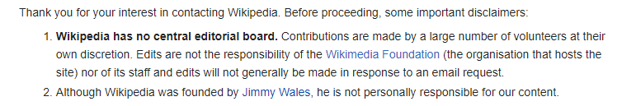
Figure 3: snippet of the "contact us" section of wikipedia
The snippet above is taken from the Wikipedia website contact us page in tools section. It indicates that since the contributors are volunteers at their own willing. There is no central editorial board provided and the founder also is not personally responsible for the content. Because someone might change something since that is how it works. And It can be said that the owner of Wikipedia is basically the volunteers as indicated in the contact section.

Accuracy of Wikipedia
Studies indicates that Wikipedia's entries had an overall accuracy rate of 80 percent Since Wikipedia can be edited by anyone at any time, articles may be prone to errors, including vandalism so Wikipedia is not a reliable source. So, it is better not to use Wikipedia for specific and critical source. There are also some spelling, grammar and punctuality errors on Wikipedia. But they provide a typo team which is dedicated to improving the quality of Wikipedia by correcting typos and misspellings. And a platform for the users is also provided which enables users to take part in correcting typos.

Coverage of Wikipedia
There is no additional software or plugin to be added to access the website. And the content is free to use.

Purpose of Wikipedia
Wikipedia's purpose is to benefit readers by acting as an encyclopedia, a comprehensive written compendium that contains information on all branches of knowledge. And the website meets the purpose by providing volunteers which are users to take part in sharing and editing information which makes its source very huge in number.

Accessibility of Wikipedia
Wikipedia is not specific to browsers, not limited to a specific screen resolution and operating system. Wikipedia is working on a project which aims to make Wikipedia accessible for users with disabilities. More specifically, accessibility means that people with disabilities can perceive, understand, navigate, and interact with Wikipedia, and that they can contribute to Wikipedia.

Web design of Wikipedia
The design of Wikipedia website goes in parallel with the purpose of the website. White spaces are provided among sections which makes it more readable and the text is also readable enough,

Judgment of Wikipedia
- On the judgment section, the writer of this document provides his own judgment of the website and might use the word I to resemble himself, and we to resemble the web community or student depending on the context.
Wikipedia might be the most used source with major disadvantage for using it. Before I put my judgment on the content of the website. There are some points which I admire about the Wikipedia website which Is the effort they are making and already made to make their site accessible to the entire world. The home page of Wikipedia lets the user to choose the language he/she prefer, the number of the language present is remarkable. With large amount of article for most of the languages.
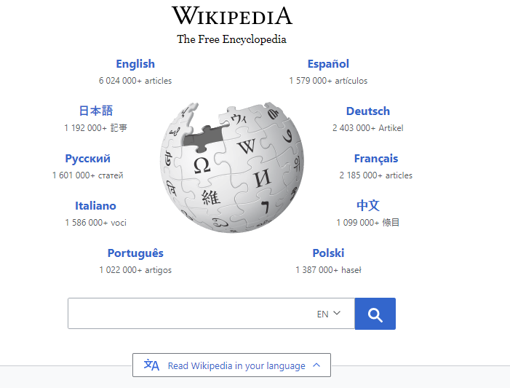
Figure 4: The home page of Wikipedia which shows the different languages

Judgment regarding the content of Wikipedia
I personally have two views on the content of Wikipedia, I think that we must not avoid using Wikipedia because of the side effect and also, we must not entirely depend on it; actually, Wikipedia must be used for a specific reason (must not be the basic source). The reason I suggest that It is not good to use Wikipedia as the basic source specially for major things like research paper and the likes of it is that, the content can be edited by anyone at any time for any reason and most of the information has not been verified by experts and can't be considered credible or reliable and the information could be quickly outdated. As a result, it makes the information of the site vulnerable to outdated information but most importantly misleading information; However, I personally think there are some occasions we must use Wikipedia. Among them it is organized nicely which makes it easy to use and navigate around, it provides the references to the information it provides, and the main reason I use Wikipedia is it can help to get started with general idea of what a topic is about. So, the articles may help you get started by providing an easy-to-read introduction of a topic. Even more useful, the articles might have references to sources that are acceptable.

Judgment regarding the design of Wikipedia
I think the design do meet the purpose of the site. However, the amount of the blue link texts on some occasions might be too much, though there is a reason for being in that way, when it is too much it affects the design hence, reading experience of the user.

Gebeya

Figure 5: The logo of Gebeya
Gebeya means marketplace in Amharic Ethiopia's national language. Its vision is to be the premier software engineering and IT training academy in Africa, while becoming the number one global IT services marketplace that matches African IT talent with clients across Africa and the rest of the world.

Currency of Gebeya
The recent blog post is almost at February 7, 2020 which is almost a month after the previous blog post. Which is somehow good on addressing the users as soon as a certain event happened relevant to the purpose of the website but not recently updated.

Objectivity of Gebeya
There is no advertisement on Gebeya website which contributes to the objectivity of the website. The way the information is present is classified in the appropriate sections and each section provides information to the intended purpose.
Figure 6: The snippet shows the navigation bar of Gebeya
The snippet above illustrates the section links which directs to different sections which are objective i.e. the sections deals only about what the title of the link indicates.

Authority of Gebeya
The contact information is clearly noted in the contact section. Which briefly indicates the specific location and the Email of those responsible for the site. The site provides all the location of their branches located in Africa and USA. which are Ethiopia and Kenya and USA. It also provides sufficient social media links on the footer. Which are there Facebook, twitter, YouTube, LinkedIn and Instagram which shows the alternative ways an individual follow them.

Accuracy of Gebeya
It appears to be unbiased with basic spelling, grammar and punctuality aspect.

Purpose of Gebeya
The purpose of the Gebeya website is Building a self-sustainable ecosystem that trains, hires and cultivates, the company has positioned itself as an organization that produces top talented African Software Engineers who understand and are specialists in several industries including AI, AgriTech, Blockchain, FinTech, Internet of Things, Media Production, Telecom, and Gaming. The website is so appealing to see with good animations which clearly supports the purpose and grabs the attentions of the user.

Accessibility of Gebeya
Gebeya is not specific to browsers, which is not limited to any specific screen resolution and operating system.

Web design of Gebeya
The design of the website clearly shows the site is indeed a site of technological professionals with sufficient white space, best animation introduction and also good color choice. The only bad thing to be considered on the design is the fact that the cursor doesn’t change when navigating on links which doesn’t give the user the feeling the cursor is actually on the link or somewhere else.

Judgment of Gebeya website
- On the judgment section, the writer of this document provides his own judgment of the website and might use the word I to resemble himself, and we to resemble the web community or student depending on the context.

Judgment regarding web design of Gebeya website
Being an institution, whose vision is to enrich people with IT professional, a good website is expected from them, in which in my perspective Gebeya website fulfill the expectation. The way the animation pops up does not interfere with other contents and looks appealing to the user but I think the cursor must somehow change when placed on links, there actually is a color change on the link but still it is not sufficient it lacks to indicate the user is actually hovering over the link which I conclude it is somehow a bit vague to have the same cursor on the link and other part of the site. Another thing I found discomforting on the site is on the meet the team section, when hovering over the people the color of the photo frame change along with the cursor but nothing happens when clicked. It would be good if little information about them is displayed when the name or image section of the individual Is clicked, which puts trust on the user.

Judgment regarding content of Gebeya website
The content of the site is good which go hand in hand with the purpose of the site. They provide a blog section that posts about there working but only 5 posts have been made, from Nov 5, 2018 to Feb 7 2020, which Is only 5 posts in almost 2 years which must be approved.

Conclusion

Reference

